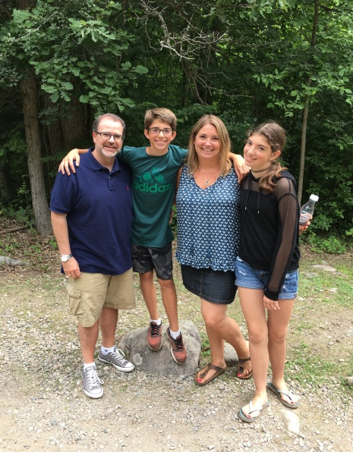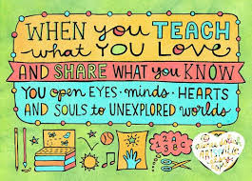  

**All About Morah Batya**

Colors: fuscia and blue

Seasons: summer/fall

Food: Falafel from Israel

Drink: Iced vanilla latte

Things I love to do: Swim, read, travel, watch my son play football or my daughter perform on stage

**ABOUT ME**

Growing up in Los Angeles, my family was very involved in our shul. I went to afternoon Hebrew school and I was very active in my youth group. I flew to Ottawa every summer to visit my grandparents and went to Jewish sleep away camp.

After high school I spent two years living in Israel. I studied at the Hebrew University and I worked on a kibbutz. When it came time to decide what to do with my life, teaching seemed like a natural fit. I moved to Toronto and completed my degrees in Jewish studies and Jewish Education.

These experiences have helped shape who I am, how I raise my children and the ways I teach my students. I am looking forward to a rich, meaningful and fun year together with your children.

**Favourites**